**Literals. Python version :- import sys**

**1.String Literals**

**2.Numerc literals  
3.Boolean literals**

**4.collections**

**5.Special**

**Data types. Print(type(x))**

1. **Numbers**
2. **String :- “ ” , ‘ ‘ , chr(),ord(),len(),str().,**
3. **Lists :-[] , appending (1) . Extending.(More)**
4. **Tuples :-()**
5. **Dictionary :-{Key:value}**
6. **Set :- {}**
7. **Frozen set :- inbuilt function of python**
8. **Boolean.**
9. **Mutable & immutable : - Changeable – non changeable**

**.**

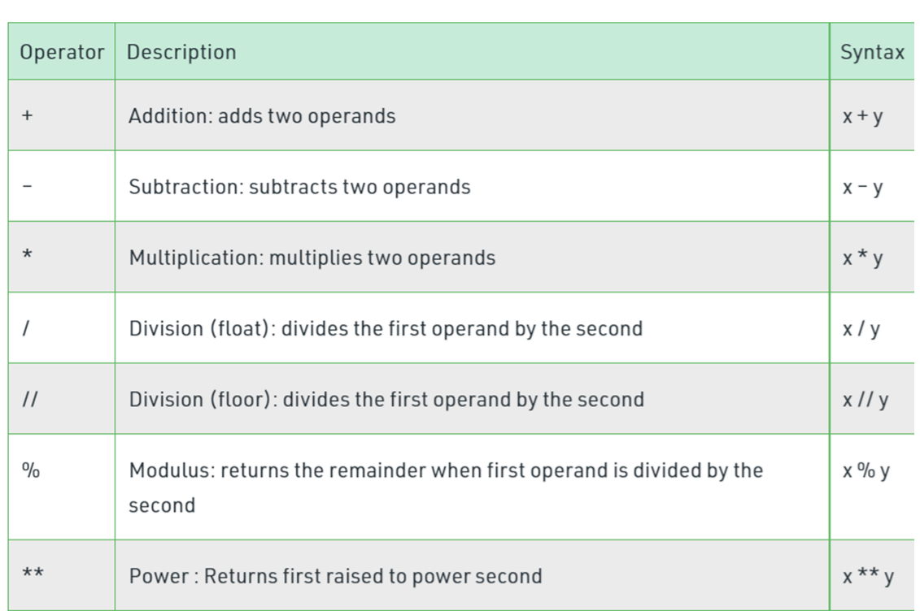

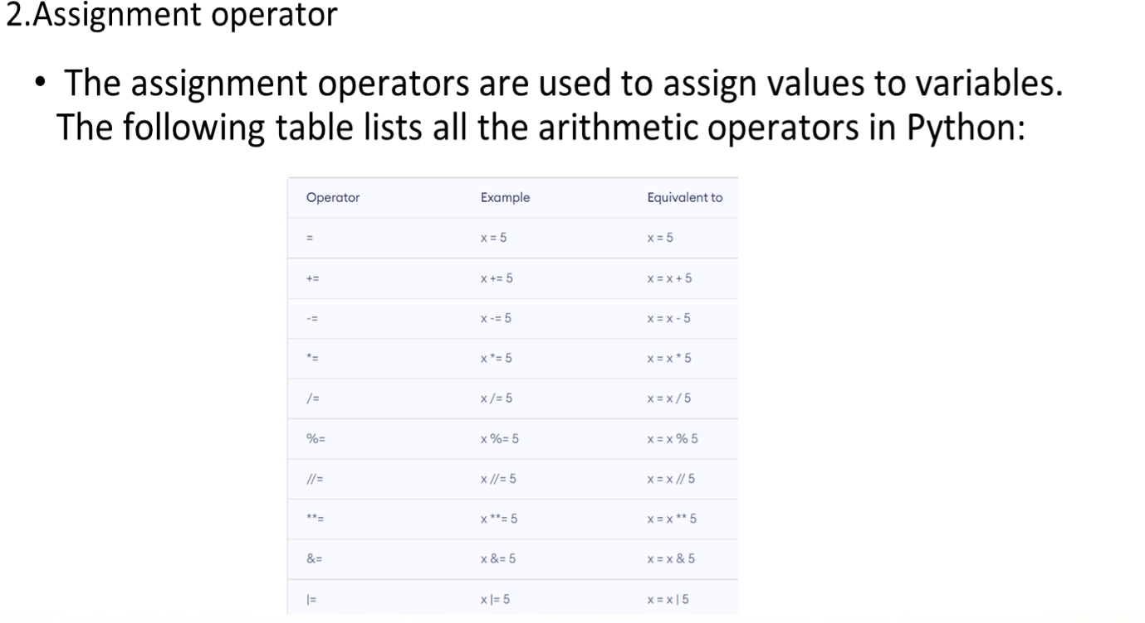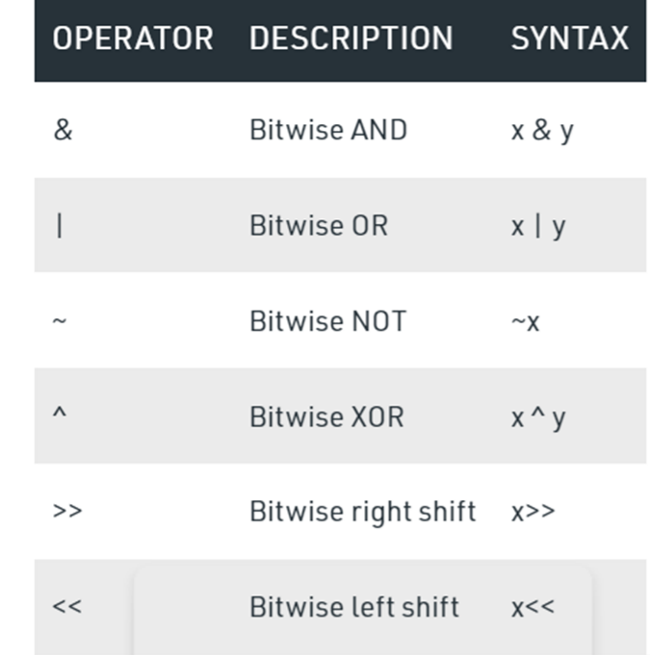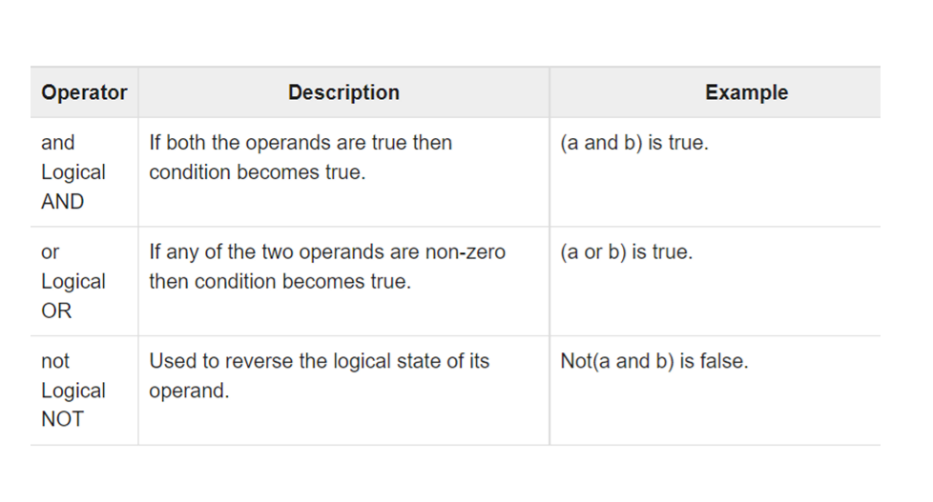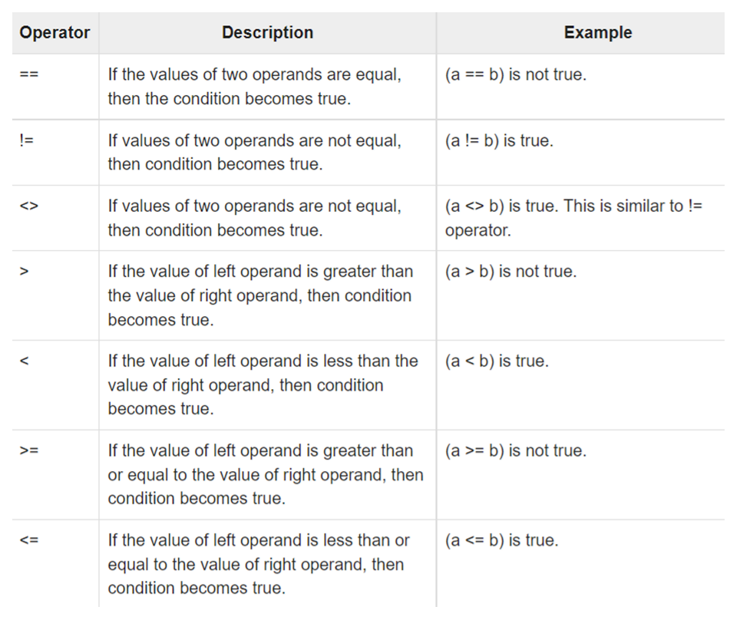

|  |  |  |  |  |
| --- | --- | --- | --- | --- |
| **Conditional** | **statements** |  | **Logical** | **conditions** |
| **if** |  | **1** | **equals** | **: a==b** |
| **-if – else** |  | **2** | **notequals** | **a!=b** |
| **-if – elif** |  | **3** | **Less than** | **a<b** |
| **Nested if** |  | **4** | **Less & equal** | **a<=b** |
|  |  | **5** | **Greater** | **a>b** |
|  |  | **6** | **Greater & equal too** | **a>= b** |

**Function :** - block of reusable code , function can be created the user also ex local , glocal

Function can created by using **:- def funname**

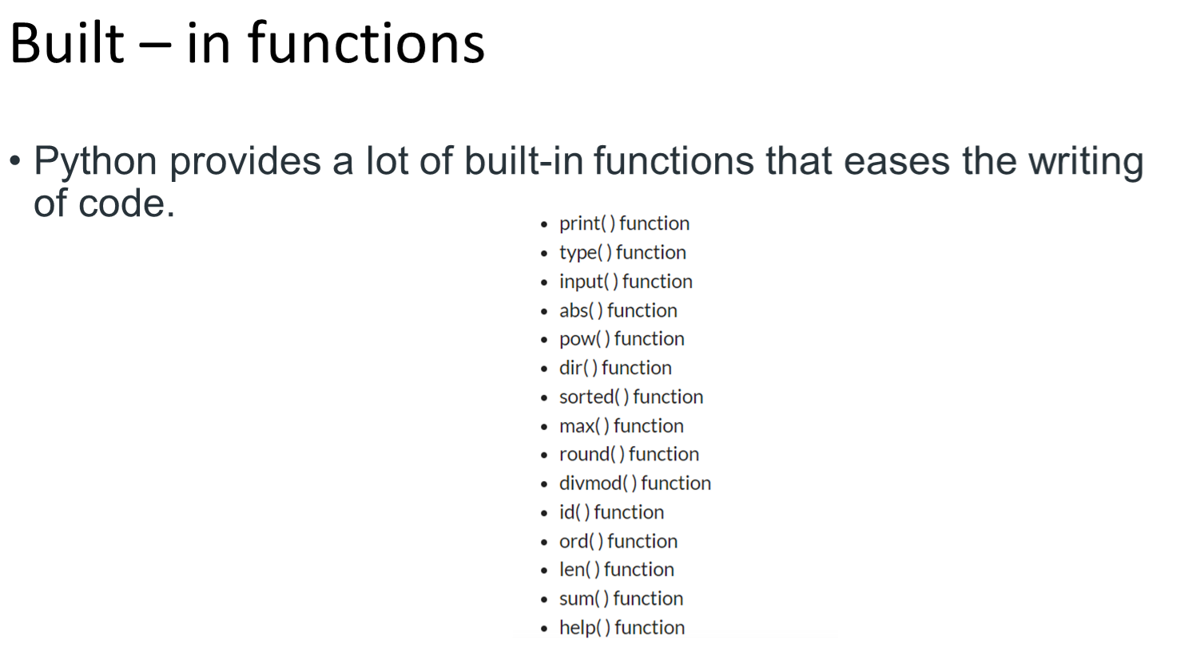

**Lambda**

**MODULES & PACKAGES.**

**CLASSES & OBJECTS:-**

**Polymorphism :- plays multiple role for (+)**

**Encapsution:- hides tha data of program for ex ( capsule)**

**Abstraction:- hides the implementation of the program.**

**panda**